**Peterson Algorithm JAVA**

**By**

**Alhaitham Gamal**

**20143114**

**Problem:**

When 2 process want to get access the same shared resource the process that tried first should access first and enter the critical section while process 2 should get blocked to access.

**Solution:**

We created simple 2 threads that show the 2 process that want to access the same resource say resource name is cin=14 we define array of Boolean that represent number of 2 process and turn represent the turn of each process and we define 2 process that care process I and j

Or first process we define its flag by true and assign turn=I then we check if turn =I and flag of other process not equal false if that it continue looping and not enter critical section if not it print variable cin and get increment it then it turns the flag of I =false then it will go to another thread apply the same.

**Figure -1**

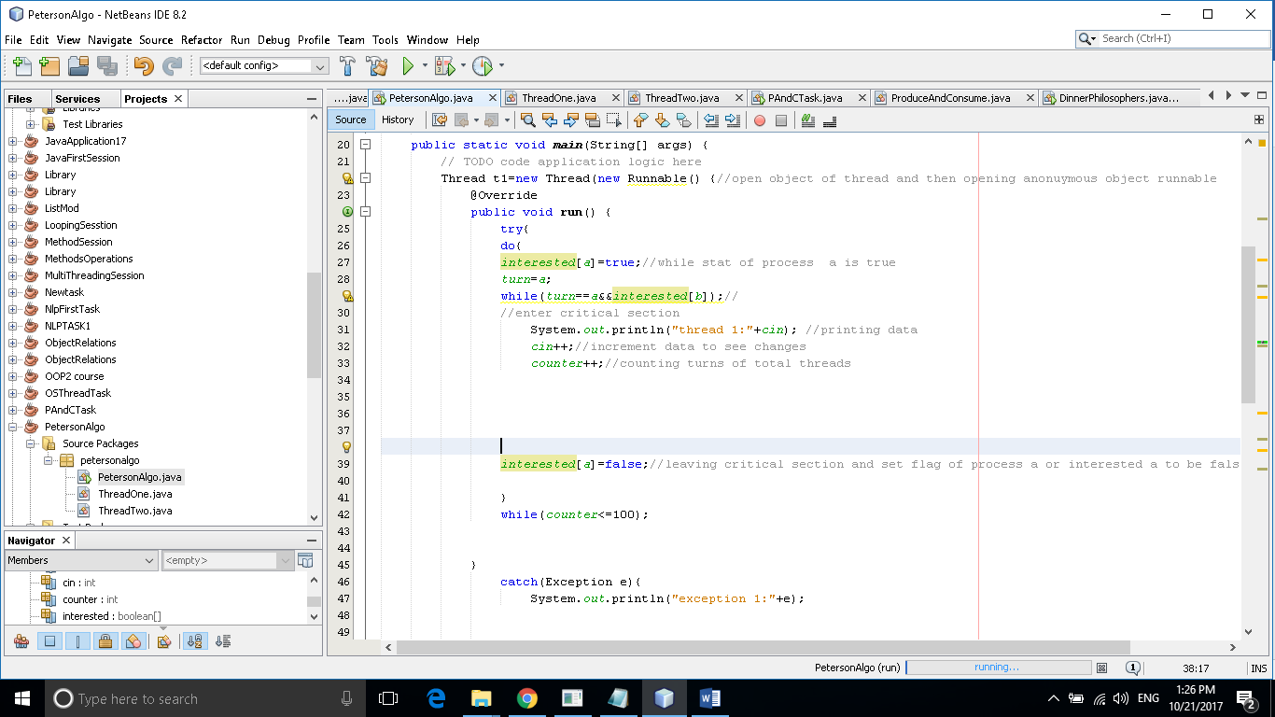

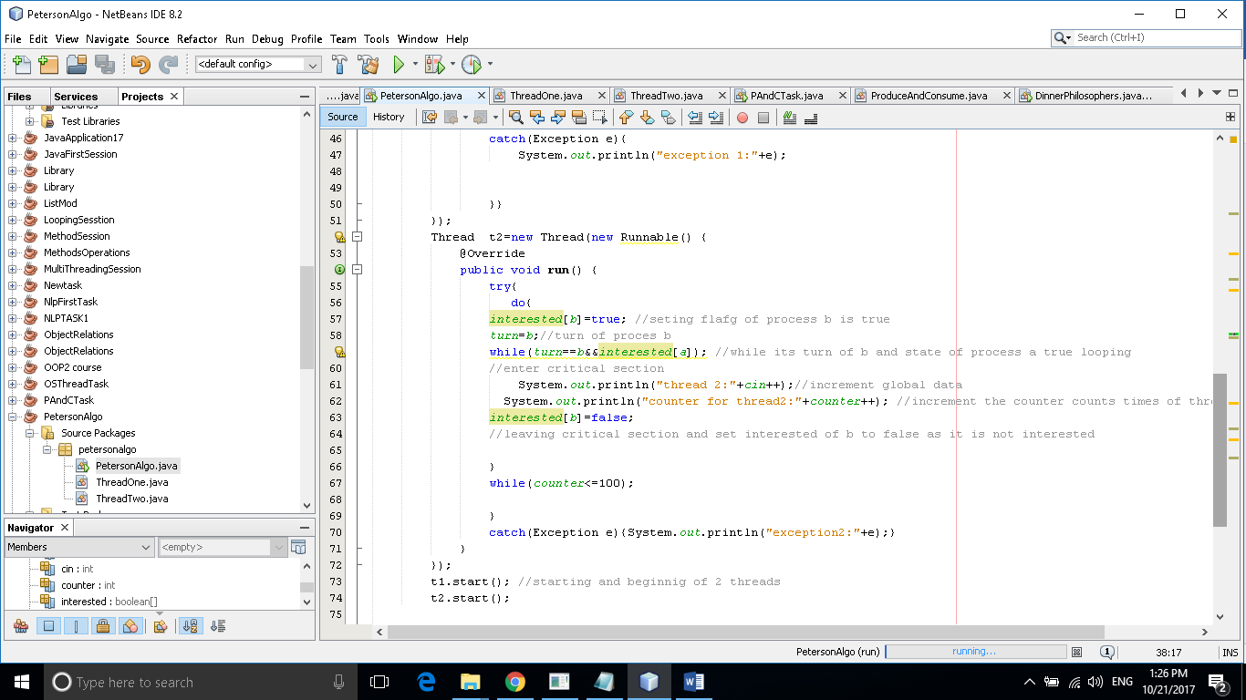**Figure-2**

**Figure-3**

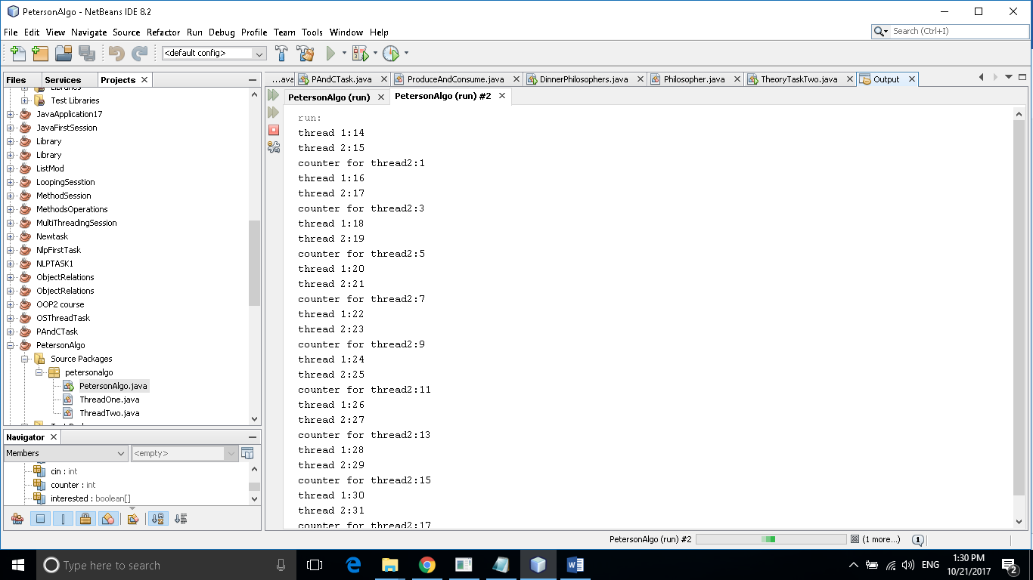

**Reference:**

**https://tushroy.wordpress.com/2011/04/15/petersons-solution-simulation-on-java/**